|  |
| --- |
| **LEARNER’S ACADEMY** |

# **DEVELOPER DETAILS:**

|  |  |
| --- | --- |
| **DEVELOPED BY** | **SOUMYA G K** |
| **GITHUB LINK** | **https://github.com/soumyare/Learner-s-Academy.git** |

# 

# **CONTENTS:**

Contents

**DEVELOPER DETAILS:** 1

**CONTENTS:** 2

**SPRINT PLANNING AND TASK COMPLETION :** 3

**CORE CONCEPTS USED IN THE PROJECT :** 3

**FLOW OF THE APPLICATION :** 4

**APPLICATION FLOW :** 5

**HOW TO RUN THE PROGRAM :** 5

**PUSHING CODE TO THE GITHUB:** 5

# **SPRINT PLANNING AND TASK COMPLETION :**

The project is planned to be completed in 3 sprints. Tasks assumed to be completed in the sprints are:

* Create database and tables.
* Connect the database to the project.
* Create models classes.
* Create a database utility class to retrieve data.
* Create login page.
* Create JSP files for all pages of the project.
* Create a servlet to get requests and send responses to the JSP files.
* Add cookies.
* Create a CSS file to format the contents.
* Debug and Test the project.
* Push the code to the GitHub.

# **CORE CONCEPTS USED IN THE PROJECT :**

• Object-Oriented: used to create and model objects for users and their credentials.

• Databases: used to store and retrieve data.

• Data Sources: used to define a set of properties required to identify and access the database.

• Collections: used some collections such arraylist to store collection of data.

• Exception Handling: used to catch problems that arises in the code especially in I/O blocks.

• Cookies: to store log-in data on the client browser.

# **FLOW OF THE APPLICATION :**

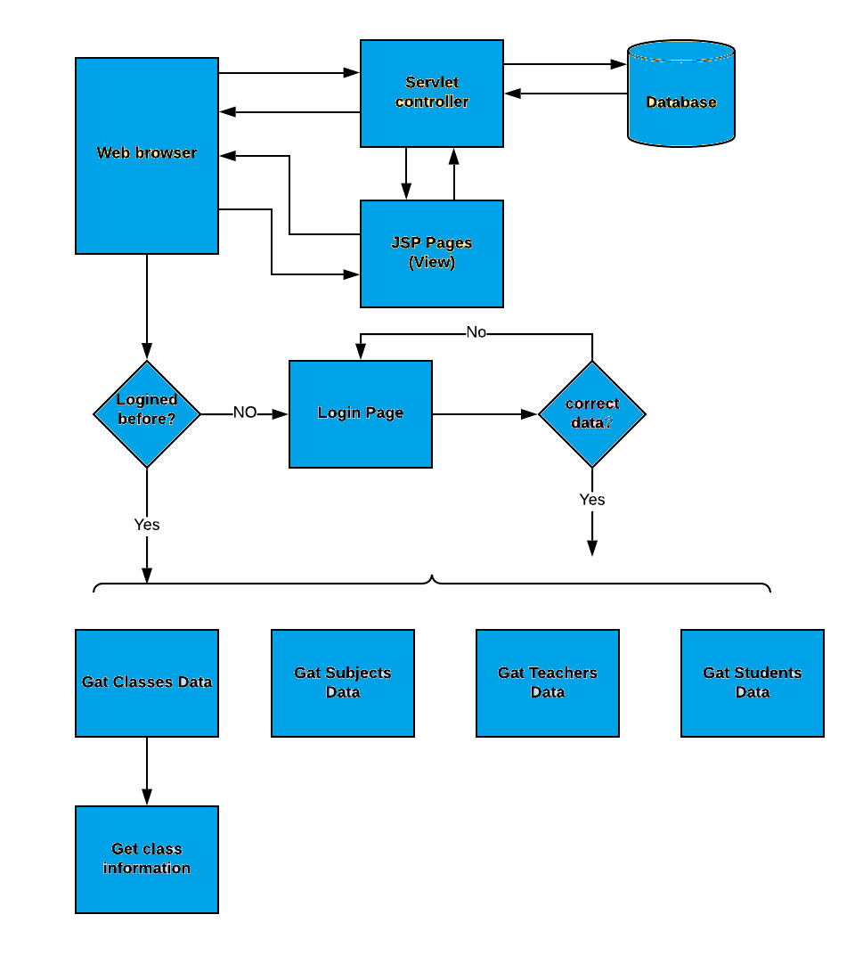

# **APPLICATION FLOW :**

* Create the project in Eclipse.
* In **com.models** package, created the java classes to initialize variables. The classes are, **Students.java** , **Classes.java** , **Subjects.java** and **Teachers.java**.
* In **com.admin** package, created the servlets are, **AdminControllerServlet.java** and **TestServlet.java** and to retrieve database **DbRetreive.java** class is created.
* Jsp pages are created to connect to the servlets.
* In database, the **administrative_portal.sql** file is uploaded from phpmyadmin and importing this file in mysql and executed.

# **HOW TO RUN THE PROGRAM :**

• Import the “database\database.sql” file to your database administration tool.

• Go to “\src\main\WebContent\META-INF\context.xml” file and open it.

• Edit the database properties such as username, password and driverClassName to be suit to your database administration tool.

• Now run program on a server.

• To login you must enter admin for both username and password.

# **PUSHING CODE TO THE GITHUB:**

**Github Link :**

**https://github.com/soumyare/Learner-s-Academy.git**